***LAB#2***

***VIGENERE CIPHER***

*WITH TABLE :*

def generate_vigenere_table():

"""Generate Vigenère table"""

table = []

for i in range(26):

row = [chr((i + j) % 26 + 65) for j in range(26)]

table.append(row)

return table

def vigenere_encrypt(plaintext, key):

"""Encrypt plaintext using Vigenère cipher"""

plaintext = plaintext.upper()

key = key.upper()

table = generate_vigenere_table()

ciphertext = ''

key_index = 0

for char in plaintext:

if char.isalpha():

row = ord(key[key_index % len(key)]) - 65

col = ord(char) - 65

ciphertext += table[row][col]

key_index += 1

else:

ciphertext += char

return ciphertext

def vigenere_decrypt(ciphertext, key):

"""Decrypt ciphertext using Vigenère cipher"""

ciphertext = ciphertext.upper()

key = key.upper()

table = generate_vigenere_table()

plaintext = ''

key_index = 0

for char in ciphertext:

if char.isalpha():

row = ord(key[key_index % len(key)]) - 65

col = table[row].index(char)

plaintext += chr(col + 65)

key_index += 1

else:

plaintext += char

return plaintext

def print_vigenere_table():

"""Print Vigenère table"""

table = generate_vigenere_table()

print(" ")

print(" Vigenere Table:")

for row in table:

print(' '.join(row))

if __name__ == "__main__":

print_vigenere_table()

plaintext = input("Enter plaintext: ")

key = input("Enter key: ")

encrypted_text = vigenere_encrypt(plaintext, key)

decrypted_text = vigenere_decrypt(encrypted_text, key)

print("\nPlaintext:", plaintext)

print("Key:", key)

print("Encrypted text:", encrypted_text)

print("Decrypted text:", decrypted_text)

*OUTPUT*

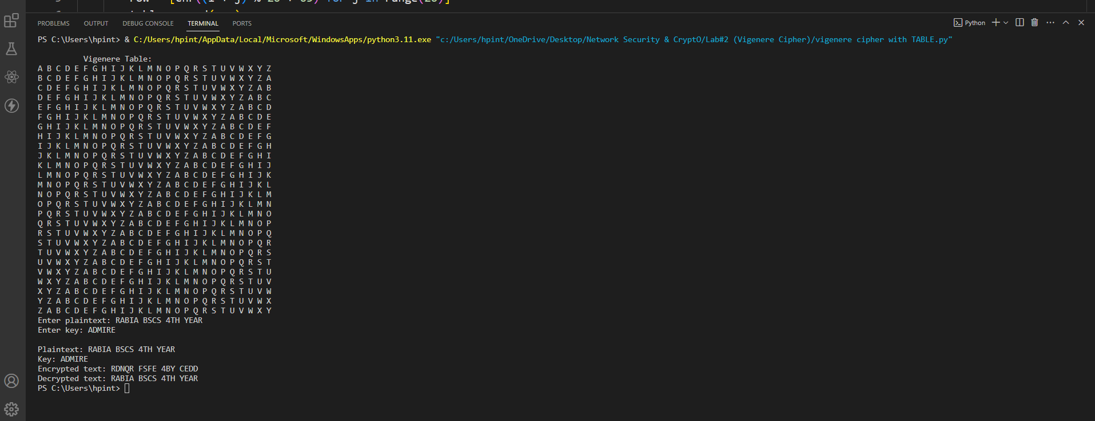

*WITHOUT TABLE :*

def vigenere_encrypt(plaintext, key):

"""Encrypt plaintext using Vigenère cipher"""

plaintext = plaintext.upper()

key = key.upper()

ciphertext = ''

key_index = 0

for char in plaintext:

if char.isalpha():

shift = ord(key[key_index % len(key)]) - 65

encrypted_char = chr((ord(char) - 65 + shift) % 26 + 65)

ciphertext += encrypted_char

key_index += 1

else:

ciphertext += char

return ciphertext

def vigenere_decrypt(ciphertext, key):

"""Decrypt ciphertext using Vigenère cipher"""

ciphertext = ciphertext.upper()

key = key.upper()

plaintext = ''

key_index = 0

for char in ciphertext:

if char.isalpha():

shift = ord(key[key_index % len(key)]) - 65

decrypted_char = chr((ord(char) - 65 - shift) % 26 + 65)

plaintext += decrypted_char

key_index += 1

else:

plaintext += char

return plaintext

if __name__ == "__main__":

plaintext = input("Enter plaintext: ")

key = input("Enter key: ")

encrypted_text = vigenere_encrypt(plaintext, key)

decrypted_text = vigenere_decrypt(encrypted_text, key)

print("\nPlaintext:", plaintext)

print("Key:", key)

print("Encrypted text:", encrypted_text)

print("Decrypted text:", decrypted_text)

***OUTPUT***

